User Story: As a Van Sales User, I want to view my assigned Journey Plan on my mobile
device so that I can visit the right customers on the scheduled day and perform necessary
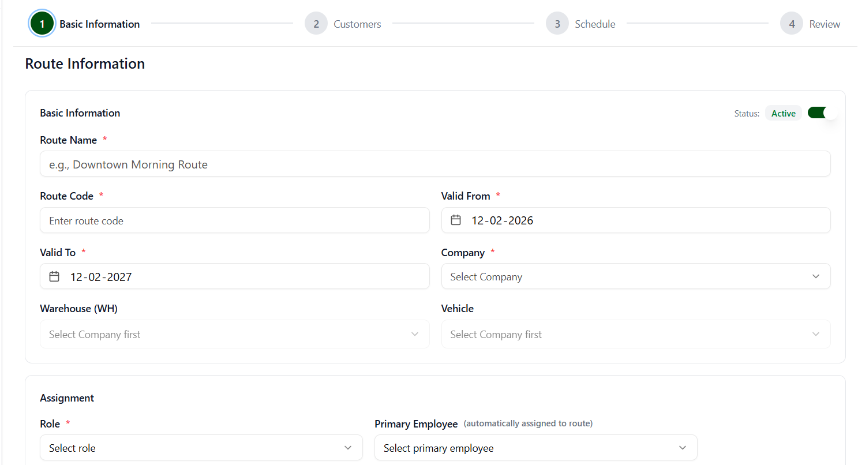
sales activities in the field.

Mobile App screen for reference
